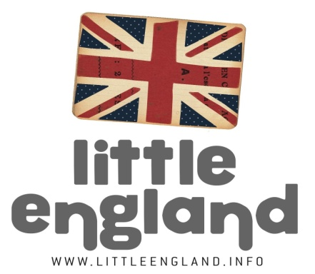
EXTRA ESCOLAR D’ANGLES
LEVEL:
2N , 3ER ESO
TOPIC:
HAPPINESS
VOCABULARY:
- COMMON ACTIVITIES
GRAMMAR:
- VERB PLUS GERUND PATTERN
RESOURCES:
- WORK SHEETS
- COMPUTER FOR TYPING
- FOOD
- CAMERA PHONE

INSTRUCTIONS:
- Print Activity sheet ‘HAPPINESS LESSON ESO’: Complete activities listed on the sheets.
- For last task, (ex. 6) write a sentence for each answer explaining WHY and email the sentences to littleenglandbanyoles@gmail.com for corrections.
- EG. I don’t mind playing football, because although it is not my favourite sport, it is quite fun!

